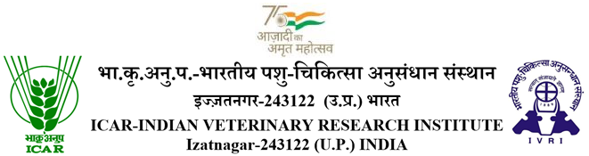

No.F.4-1/2020-Academic Dated: 26.04.2022

NOTIFICATION

In continuation to this office Notification of even number dated 15.01.2022, please find annexed the Revised Academic Calendar for 2nd Semester 2021-22 (for 1st year’s newly admitted PG Students). All the academic activities mentioned in the term calendar will be carried offline, following the COVID guidelines/ advisories issued time to time by central/ state Governments. All the PG students are advised to register themselves on AMS and peruse their academic activities as per revised term calendar and SOPs on the subjects available on institute website at www.ivri.nic.in. Registration of the students for 2nd semester 2021-22 session will be opened from 23.05.2022 onward as per academic calendar.

Academic Coordinator
Copy for information & necessary action to:

- All the Chairperson, Board of Studies (BOS)/HD, ICAR-IVRI, Izatnagar/ Mukteswar.
- The Joint Director, ICAR-IVRI, Mukteswar/ Hebbal, PO HA Farm, Bengaluru
- The Station Incharges, ICAR-IVRI Regional Stations, Palampur/ Mukteswar/ Kolkata.
- The Incharge, ARIS Cell, ICAR-IVRI, Izatnagar, with the request to kindly upload the PG Term Calendar on the Institute’s website.
- All the 1st year’s PG (PhD/MVSc) students, through their respective HDs & BOS Chairpersons, ICAR-IVRI, Izatnagar.
- The Controller of Examination, ICAR-IVRI, Izatnagar.
- The AAO (A&F), ICAR-IVRI, Izatnagar
- AMS Office with the request to please upload the notification on AMS
- The PS to Director (Academic), ICAR-IVRI, Izatnagar.
- The PS to Joint Director (Academic), ICAR-IVRI, Izatnagar.
- The PS to Registrar, ICAR-IVRI, Izatnagar.

Revised
TERM CALENDAR
2nd Semester: 23rd May, 2022 to 14th September, 2022

Sl.  No. | Events | 2nd Semester
1. | Date of Registration of Students and Payment of Institute’s /*Hostel fee | 23.05.2022
2. | Payment of Institute & *Hostel fee with late fee | 24.05.2022 to 26.05.2022
3. | Last date of submission of roster forms | 27.05.2022
4. | Last date for adding/dropping a course | 30.05.2022
5. | Date of submission of courses registered by the HDs | 02.06.2022
6. | Quiz Examination | 23.06.2022 to 27.06.2022
7. | Last date of submission of result of Quiz | 30.06.2022
8. | Mid-term examination | 22.07.2022 to 29.07.2022
9. | Last Date of Submission of Result of Mid-term examination | 03.08.2022
10. | Last date of submission of result of Special Problem, Seminar & Assignment | 06.08.2022
11. | Final examinations (Audit/Non credit courses) | 08.08.2022 to 15.08.2022
12. | Last date of submission of results(Audit/Non credit courses) | 17.08..2022
13. | Semester final examination | 18.08.2022 to 09.09.2022
14. | Semester Break | 10.09.2022 to 14.09.2022
15. | Declaration of Result of Semester end examination | 14.09.2022

NOTE:
- During all the academic activities the COVID guidelines strictly be followed

- *Hostel fee in respect of the PG students who are coming first time to join IVRI in the 2nd Semester will be deposited on actual Hostel allotment on the arrival of students in the campus, depending on the availability and rank in the merit list.

- The semester will be concluded by 14.09.2022. In academic calendar, all the holidays will be counted as working days except Sundays.

- In case holiday falls on any above date, the schedule will be shifted to next working day.

